CSC256 Final Exam Cheatsheet

Summary of Schedulability Analysis Algorithms
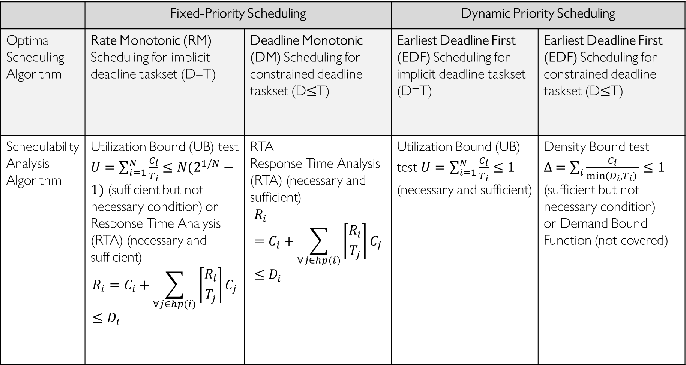
PCP Blocking Time
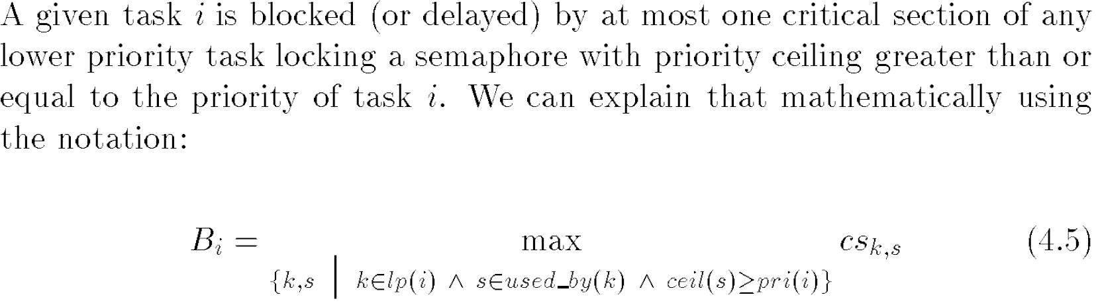
Consider all lower-priority tasks (k∈lp(i)), and the semaphores they can lock (s)
Select from those semaphores (s) with ceiling higher than or equal to 〖𝑝𝑟𝑖(𝑖)=𝑃〗_𝑖
Take max length of all tasks (k)’s critical sections that lock semaphores (s)

